
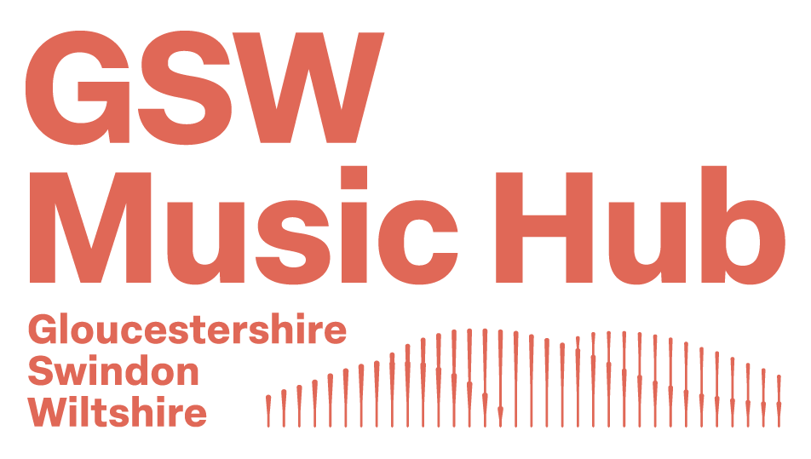

Music Development Grants

GSW Music Hub, the county’s music education hub, is working to achieve the ambitions of the Department for Education for Music Education in England and our own identified needs for young people in Gloucestershire, Swindon and Wiltshire. We want to enable all children and young people to learn to sing, play an instrument and create music together, and have the opportunity to progress their musical interests and talents, including professionally.

GSW Glos (the Gloucestershire arm of the overarching GSW Hub) has a core team of four delivery partners, all of whom bring different strengths in music education, working with the county’s schools and other organisations serving young people from 0-18yr (or 25yrs for young people with SEND). Part of that grant has been set aside to help any organisation associated with the hub (providers, schools, others with an interest in music education) develop an aspect of music education that addresses the needs of young people in their area/setting.

Applications are invited for grants to reach more young people with music and to develop their music education. The fund aims to increase the money spent on music education and will therefore require evidence of match funding from income, other grants or money raised to support a particular project.

Grants of up to £500 are available to help schools or community groups to respond to vision or specific goals of the grant funding:

- All children and young people receive a high-quality music education in the early years and in schools
- All music educators work in partnership, with children and young people’s needs and interests at their heart
- All children and young people with musical interests and talents have the opportunity to progress, including professionally

Supporting your colleagues:

We also are happy to help you to share resources and information for the benefit of other individuals and organisations working with young people. If you have any resources or information you would like to share with us, or would like to discuss other ways in which we could work together outside of the funded programmes, please contact us:

GSW Music Hub
Colwell Arts Centre, Derby Road, Gloucester GL1 4AD
T 01452 427242 E gswmusichub@gloucestershire.gov.uk W https://www.gswmusichub.org.uk/

How to apply:

The pro-forma must be completed by a representative of the bidding organisation

- Complete the attached pro-forma. Please read the criteria and priorities below and consider these when completing the pro-forma

- Once completed, please return your pro-forma to: gswmusichub@gloucestershire.gov.uk

- There is no deadline to submit a Music Development Grant (MDG) application, as this is a rolling programme. Subject to funds being available we will assess your application and respond to you within three weeks of submission.
Please note that grants will be given subject to qualification against the criteria and suitability against the priorities list. Submitting an application does not guarantee you will be successful in receiving a grant.

Criteria:

- The bidder must have appropriate insurance and safeguarding in place. If your organisation is not a school, then you will need to provide relevant evidence.

- You must explain how the activity or equipment you use with the MDG integrates into your current music offer; ensuring cohesive progression routes. However, a MDG cannot be used to fund existing activity. In the case of a school this means the grant cannot be used to fund timetabled activity during the school day.

- The bidder must aim to contribute at least 50% financially and this must be listed in the budget section of the pro-forma. Where this is a significant barrier then please outline your challenges and the amount you can offer as match funding.

- You must demonstrate a legacy plan for after the MDG grant runs-out. (E.g. the equipment purchased will be used in music activity every year or you will use young people’s contributions to retain the ensemble.)

Other information:

- Any grant you are allocated will be specifically for the activity/project bid for in your application.

- The grant should be spent in the academic year it is assigned to you.

- Any underspend of a project would need to be returned to the GSW Music hub before the end July in that academic year.

- Any unknown / additional costs incurred during the project will not be covered and the bidding organisation will be liable for these costs.

- This grant must not pay towards any subsidised schemes provided to schools / organisations by GSW Delivery Partners.

- GSW Music Hub and Arts Council England should be acknowledged in any media / communications regarding the subsidised project.

GSW (Glos) MUSIC HUB – MUSIC DEVELOPMENT GRANT

Bidding Organisation/School |  |  |  |  | Contact name:
Email: |  |  |  |  | Role:
1.What would the Music Development Grant be used for? (i.e. What will the money be spent on) (max 200 words)
2. What would be the outcomes for your pupils?
3. Type of activity you are bidding for:
Early Years |  |  |  | CPD for Teachers (to help deliver quality musical opportunities for pupils)
Instrumental Tuition |  |  |  | Resources to help deliver a new musical initiative
One off musical enrichment opportunity  (i.e. a workshop) |  |  |  | Regular musical enrichment opportunity (i.e. a weekly group for pupils to attend)
Progression route (to help develop musical skills further or explore career opportunities) |  |  |  | Partnership working – collaborative musical experience with another establishment / organisation (i.e. a MAT project or working with another charity)
4.If known, what age groups will benefit from this grant?
5. Will you charge children and young people to participate (in any associated activity), if so how much? What will you do to reach those who may not be able to afford any charges?
6. Please explain how the activity or equipment the MDG funds will be used and how it integrates into the music offer, ensuring cohesive progression routes
(a MDG cannot be used to fund existing activity, unless you can demonstrate how it will add significant value to the current activity)
7. Please demonstrate a legacy plan for after the MDG runs-out. E.g. the equipment purchased will be used in music activity every year or you will use student contributions to retain the ensemble (max 200 words)
8. Do you need GSW to assist in sourcing an appropriate music practitioner or resources?
Budget Expenditure: |  |  |  |  | Budget Income:
Provider |  | £ |  |  | GSW Glos Grant requested |  | £
Instruments |  | £ |  |  | Bidding Organisation contribution |  | £
Resources |  | £ |  |  | Pupil contribution |  | £
Other (please specify) |  | £ |  |  | Other (please specify) e.g. PTA funds, other grants |  | £
TOTAL Expenditure |  | £ |  |  | TOTAL Income |  | £
If you need support to complete this form, please reach out to us via phone or email and we will be very happy to help.

